VGA

The connector is like this:

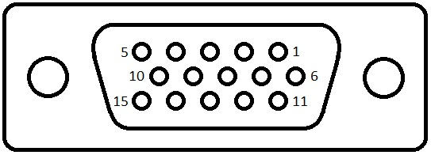

And the pins are:

|  |  |  |
| --- | --- | --- |
| **Pin No.** | **Pin Name** | **Description** |
| 1 | RED | Red video (75 ohm, 0.7V peak-to-peak) |
| 2 | GREEN | Green video (75 ohm, 0.7V peak-to-peak) |
| 3 | BLUE | Blue video (75 ohm, 0.7V peak-to-peak) |
| 4 | ID2 / RES | Monitor ID Bit 2 / Reserved |
| 5 | GND | Ground |
| 6 | RGND | Red Ground |
| 7 | GGND | Green Ground |
| 8 | BGND | Blue Ground |
| 9 | KEY | +5V DC output from graphic card |
| 10 | SGND | Sync Ground |
| 11 | ID0 / RES | Monitor ID Bit 0 / Reserved |
| 12 | ID1 / SDA | Monitor ID Bit 1 / I2C bi-directional data line |
| 13 | HSYNC | Horizontal Sync |
| 14 | VSYNC | Vertical Sync |
| 15 | ID3 / SCL | Monitor ID Bit 3 / I2C data clock |

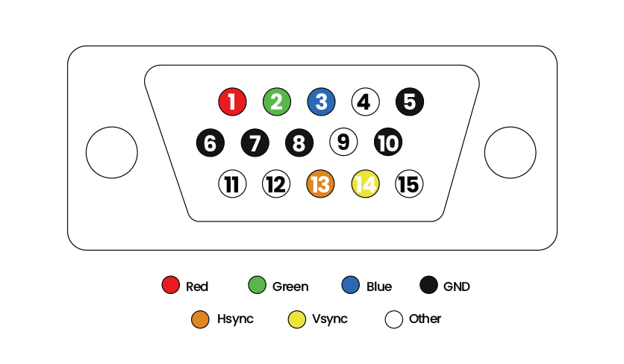

Lets start with 640*480 @60Hz

Signals are:

Red, Green, Blue, HSync, VSync.

A screen begins a new line when it receives a **horizontal sync** and a new frame on a **vertical sync**.



For 640*480 @60Hz we have:

|  |  |  |
| --- | --- | --- |
| **Parameter** | **Horizontal** | **Vertical** |
| Active Pixels | 640 | 480 |
| Front Porch | 16 | 10 |
| Sync Width | 96 | 2 |
| Back Porch | 48 | 33 |
| Total Blanking | 160 | 45 |
| Total Pixels | 800 | 525 |
| Sync Polarity | negative | negative |

The blanking interval has three parts: **front porch**, **sync**, and **back porch**. The front porch occurs before the sync signal, the back porch after.

Therefore, including blanking, we have a total of 800x525 pixels.

We can rearrange the pixel arrangement to:

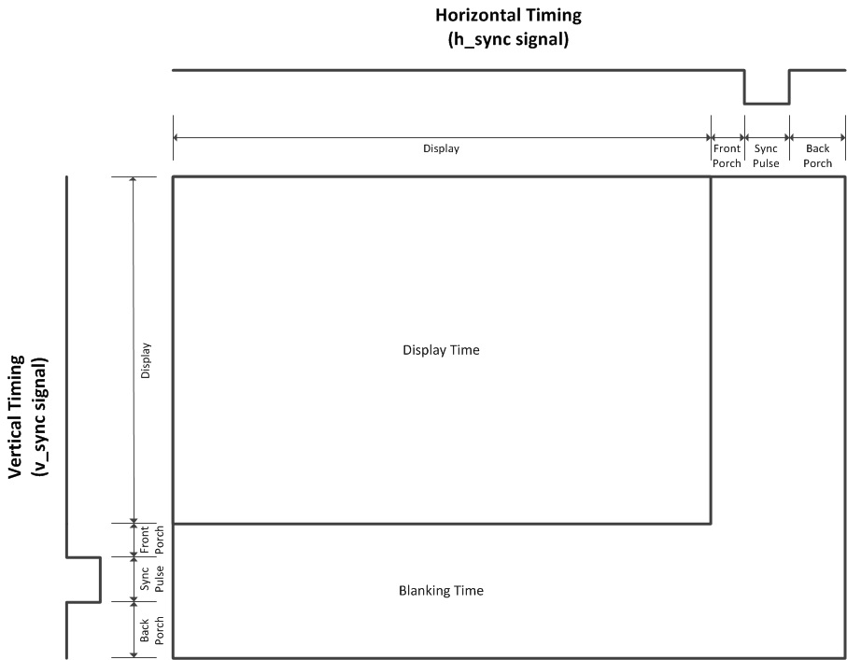

The refresh rate is 60 Hz, so the total number of pixels per second is:

800 x 525 x 60 = 25,200,000

Therefore, we want a **pixel clock** of 25.2 MHz.

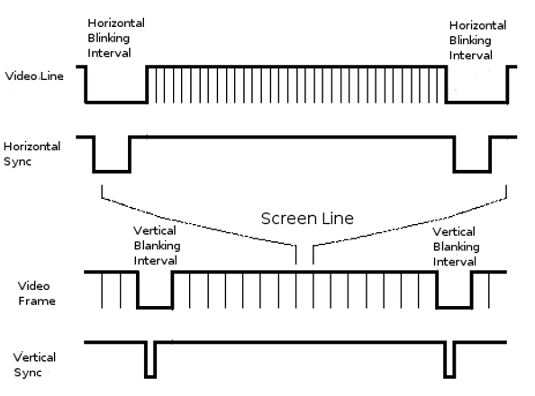

HSYNC and VSYNC signals are a train of squared pulses of +5V (+3.3V serves too) whereas RGB signals take values in a continuous (analog) voltage range from +0V (absolutely dark) to +0.7V (maximum brightness).

Bitmap file format

Bitmap file header is:

|  |  |  |
| --- | --- | --- |
| Offset HEX/DEC | Size (Bytes) | Purpose |
| 00/0 | 2 | The header field used to identify the BMP and DIB file is 0x42 0x4D in hexadecimal, same as BM in ASCII. It can following possible values.* BM – Windows 3.1x, 95, NT, … etc. * BA – OS/2 struct bitmap array * CI – OS/2 struct color icon * CP – OS/2 const color pointer * IC – OS/2 struct icon * PT – OS/2 pointer |
| 02/2 | 4 | The size of the BMP file in bytes |
| 06/6 | 2 | Reserved; actual value depends on the application that creates the image |
| 08/8 | 2 | Reserved; actual value depends on the application that creates the image |
| 0A/10 | 4 | The offset, i.e. starting address, of the byte where the bitmap image data (pixel array) can be found. |

DIB Header or info header:

|  |  |  |
| --- | --- | --- |
| Offset HEX/DEC | Size (Bytes) | Purpose |
| 0E | 4 | Size of InfoHeader =40 |
| 12 | 4 | Horizontal width of bitmap in pixels |
| 16 | 4 | Vertical height of bitmap in pixels |
| 1A | 2 | Number of Planes (=1) |
| 1C | 2 | Bits per Pixel used to store palette entry information. This also identifies in an indirect way the number of possible colors. Possible values are:  1 = monochrome palette. NumColors = 1  4 = 4bit palletized. NumColors = 16  8 = 8bit palletized. NumColors = 256  16 = 16bit RGB. NumColors = 65536  24 = 24bit RGB. NumColors = 16M |
| 1E | 4 | Type of Compression  0 = BI_RGB no compression  1 = BI_RLE8 8bit RLE encoding  2 = BI_RLE4 4bit RLE encoding |
| 22 | 4 | (compressed) Size of Image  It is valid to set this =0 if Compression = 0 |
| 26 | 4 | horizontal resolution: Pixels/meter |
| 2A | 4 | vertical resolution: Pixels/meter |
| 2E | 4 | Number of actually used colors. For a 8-bit / pixel bitmap this will be 100h or 256. |
| 32 | 4 | Number of important colors  0 = all |

Color table:

present only if Info.BitsPerPixel less than 8    
colors should be ordered by importance:

|  |  |  |
| --- | --- | --- |
| Offset HEX/DEC | Size (Bytes) | Purpose |
| 36 | 1 | Red intensity |
| 37 | 1 | Green intensity |
| 38 | 1 | Blue intensity |
| 39 | 1 | unused (=0) |